|  |
| --- |
|  |



**5 October 2012** **The Weekly Bulletin of Rotary Club of Kathmandu Mid-Town** **Bc-5.10/012-13**

District : 3292 Web:www.rotarymidtown.org.np Club Id : 26776

**OCTOBER IS VOCATIONAL SERVICE MONTH**

Vocational Service is the way Rotary fosters and supports the application of the ideal of service in the pursuit of all vocations. Inherent in the Vocational Service ideal are:

1) Adherence to and promotion of the highest ethical standards in all occu­pations, including faithfulness and fidelity to employers, employees, and associates, and fair treatment of them and of competitors, the public, and all those with whom one has any business or professional relationships

2) The recognition of the worthiness to society of all useful occupations, not just one’s own or those which are pursued by Rotarians

3) The contribution of one’s vocational talents to the problems and needs of society.

Friday, 28 September:

**DG's Club visit / Dinner Meeting**

**3rd Club Assembly of the Year 2012-13**

President Devendra welcomed District Governer Yogendra Man Pradhan, First Lady Rama, District Secretary and other officials and handed over the floor to DG for conducting the Club Assembly. Chairpersons of the respective committees presented their activity reports and future plans. DG Yogendra thanked President and committee chairpersons for their efforts and emphasized on the following:

- On Membership Development, the Club to focus on both retention as well as new member induction;

- On Public Relations, since there is a District Journalists Award in place, the Club should consider inviting

identified Journalist as guests from time to time to draw their attention on Rotary’s mission and goals

and get their support on highlighting them;

- On Club Administration, while monitoring attendance in the Club’s weekly meeting, 100% attendance

should be given to all Club members in District leadership including DG;

- On District resources, Club should put extra efforts to share District resources in the Club activities.

DG Yogendra called upon the Club to retain its pride of place as the most eminent Club in the District by encouraging a few members to become Major Donors as well as for as many members of the Club to contribute to become PHF and MPHF Fellows.

DG also assured that he would be effortful to bring RI President Sakuji Tanaka in the Club’s Charter Night 19 Nov as he is scheduled to be in Kathmandu during 3rd week of November on District visit program.

DG also released the monthly e-bulletin September 2012 issue of ‘Kaleidoscope’ of ‘Rotaract Club of Kathmandu MidTown on the occasion.

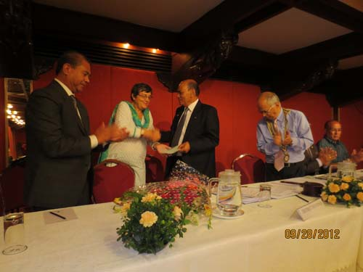 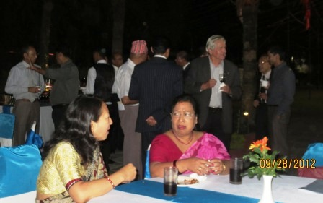

# Weekly Meetings and Programs :

|  |  |  |
| --- | --- | --- |
| Date | Program/Speaker | Program/Topics of Presentation |
| 5 Oct 2012 | US Ambassador Peter Bodde | Where I have been since last seeing you all……. |
| 12 Oct 2012 | Catherine Sue Jenson | My work at Sheer Memorial Hospital |
|  |  |  |

Friday, 5 October:



Peter W Bodde, US Ambassador to Nepal, will be with us as the guest speaker. He was

in Nepal, during 1982-84 in his career assignments at the US Embassy, and as deputy

chief of mission at the Embassy, from 1994 to 1997. He was associated with Rotary Club

of Kathmandu Mid-Town during his second assignment in Kathmandu.

He served as US Ambassador to Malawi from September 2008 to July 2011.

HE Peter Bodde will be sharing with us experiences that he gained in his varied assignments around the world. Peter Bodde speaks German, Bulgarian and Nepali too!

Four ways to fight famine:

**A**cross much of Africa, food runs out with such regularity every year that villagers call this time of starvation “the hunger season.” The new grants under The Rotary Foundation’s Future Vision Plan are helping subsistence farmers there and elsewhere produce enough food to feed their families and sell in the market. With the extra income, parents can pay for medical care and send their children to school – critical steps in the long-term effort to eliminate hunger. Community members provide input for the grant projects, which are designed to continue well into the future. Here are four strategies, developed by Rotarians and funded by global grants, to end the cycle of hunger.

**Introduce new cash crops.** The village of Mpambire, Uganda, where the average family lives on US$300 a year, has endured two crises: the AIDS epidemic, which left many widows and orphans, followed by a blight on coffee plants, the community’s primary source of income. A project is teaching about 200 women and unemployed youth how to grow passion fruit, pineapples, tomatoes, and peppers for sale in the markets. They’re also learning the basics of running a small business through instruction in saving, borrowing, and bookkeeping. And about 350 small farmers are receiving fertilizer and higher-yield maize seeds.Sponsor Rotary clubs:Whistler, B.C., Canada; Muyenga, Uganda; Project budget:US$45,750

**Teach organic farming.** About 300 farmers in Uluthe Mungao, Kenya, are learning about chemical-free soil enrichment, composting, pest and weed control, seed curing and selection, and postharvest storage. The training program has helped boost half-acre yields to about eight times what they were before; future harvests are expected to generate 20 times as much produce. The project also has funded two greenhouses, a footbridge, toilets, and protection for 10 natural springs. Sponsor Rotary clubs:Woodbury, Minn., USA; Kisumu Winam, Kenya; Project budget:US$42,550.

**Provide better cows for dairy farming.** In India, the world’s leading milk producer, most families own a cow but don’t have any surplus milk to sell. A project in Pune is providing households with cows that are cross-bred to yield more milk so families can earn extra income in the market. They also receive training in cattle raising and dairy practices. Sponsor Rotary clubs:Longtan, Taiwan; Poona North, India; Project budget:US$65,041.

**Open an agricultural training school.** When food runs out between harvests in Kisoga, Uganda, villagers must forage in the wild. A new school, part of Makerere University, intends to create a pool of agricultural professionals to boost household incomes and local harvests. The program will train about 60 students a year to work in nurseries, large-scale and family-run farms, fertilizer businesses, and seed companies. The community and the local Catholic diocese contributed 6 acres of land and the building for the school, which will operate a farm to raise additional money. Sponsor Rotary clubs:Firenze Brunelleschi, Italy; Mukono, Uganda; Project budget: US$35,216

- Katie Hills, *The Rotarian - September 2012 Source:*Rotary International News

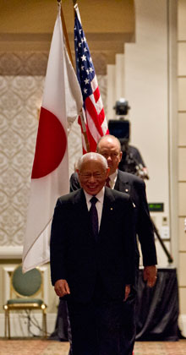

In Japan, we place great importance on the value of work. Whatever we are called to do, we

should do it to the very best of our abilities, with dignity and with pride. Whether the job is

running a country or shining shoes, there is honor in every vocation...

**RI President Sakuji Tanaka**

On Lighter Side :

Click here ⇩



**A THOUGHT FOR THE DAY:**

**“A superior man is modest in his speech, but exceeds in his actions.”**

**- Confucius**

*courtesy:* Rtn Dr Isabella C Bassingana Khadka

**Great Quotes:**

Never Make Permanent Decision On Temporary Feelings.

**Can you find out what number comes next?**

**1.. 2.. 6.. 42.. 1806..**

If you can, you have a very fine IQ ! 3263442



*tesy:* Rtn Dr Isabella C Bassingana Khadka

NB: If you have any information/photo that may be of interest to Rotarians send them to

BC Editor: RR Shrestha email: rryesrr@gmail.com

## 5 Oct 2012 The Weekly Bulletin of Rotary Club of Kathmandu Mid-Town bc-5.10/012-13